

**Project Review**

**Software Project Management**

Consumer Service Website for Party Hall Booking

Under guidance of

Prof. R.K. Singh (SCSE)

Group members:

Kunwarjeet Singh (12mse1086)

**Abstract**

We are going to develop a consumer service website where people can book halls for various type of parties. Currently there are no available websites in the market for this kind of service. Business owners can advertise with us based on membership subscription and consumers can search for a hall , review them , book them for a party. We will also develop a review system for this where users can review, rate, share a hall and rankings will be given to halls based on these. In this project we will show you the **Business Case Document, Activity network, Stepwise Planning Document** and **live demo** of website on **AWS cloud**.

**Modules**

* **Login/register**: Login using social networking sites or after registering.
* **Business/Advertise With Us**: Email verification for business owners registering with us.
* **Members Subscription**: platinum,gold,silver,bronze subscription. Various benefits based on subscription.
* **Hall Profile Dashboard**: Registered member can update his hall details.
* **Main page view**: Different type of halls, advertisments, top trending..
* **Category view/Search view**
* **Hall Details View**: Details of hall, services provided by them, charges and other facilities provided by them.
* **Review System**: Users can write reviews for various halls.

**Software tools used**

* WAMP server
* Notepad++ text editor
* Putty
* Filezilla
* Amazon EC2 Compute Engine

**Languages to be used**

* HTML5 , CSS3 , Bootstrap Framework
* Javascript , Jquery , AJAX
* PHP, Laravel Framework
* MySQL

**Business Case Document**

## Introduction

## There is a huge need of an online platform where people can easily search for a Party hall within a City , can know about overall approx. cost, when halls will be available , review them etc and for businesses who want to promote their Party Halls online on one specific platform. There is no this kind of B2C E-Commerce.

## The Proposed Project

## The idea our proposal is to create an Online Platform for Booking Party Halls. There is too much scope in this, still we don't have a one proper platform where consumers can use the service easily. We will be giving flexibility in advertising and booking to both Businesses and Consumers. Our main functionality will be where consumers can easily know about the pricing via our pricing calculator.

## The Market

## There is no competitor platform for this kind of consumer service. We might consider zomato , but for now they are providing services for Online Food Ordering and Restaurants revewing. They can capture this market very quickly as they have huge name. But Still if we act quickly and come up with a great service we can beat them.

## Benefits

Following Benefits may be possible after this -

* Increased Income from Subscriptions for Business Promoters
* Income generated via advertising. Members may advertise for their Party Hall on our main page.
* Increased traffic as one site for all.
* Increased traffic will lead to High page Ranking and increase in profit via ads.
* Increased Market Share
* Improved Customer Service

## Outline Implementation Plan

* Project Plan review and Completion
* Project Kickoff
* Hardware-Software will be purchased and Online Party booking System will be created in a web-based environment and tested by the IT Development Team.
* Marketing of the website will be done via the marketing team.
* Web-based product will be populated with the businesses who want to add their business to our site.
* Project will go live in after a certain number of subscriptions.
* Maintenance team will be keeping product up to-date
* Closeout/Project Completion

## Costs

* Following are the cost estimates for the first year-
* Amazon EC2 Compute Engine (IAAS) Rs 41025
* Domain Rs 650
* Email Service Rs 2100
* SMS Pack Rs 4500
* Toll-free-no Rs 12000
* Brand & logo registration Rs 8000
* Other Licences Rs 8000
* Software Training Rs 40000
* Marketing Rs 2-5 Lacs
* Maintenance Rs 30000

## As user traffic expands Cloud server will be upgraded.

## Total Initial Investment Cost : 1.5 Lacs approx excluding Marketing Cost

## The Financial Case

Income depends on following -

**Businesses**

Type of Subscription chosen by businesses [yearly]

* Platinum Rs 36000
* Gold Subscribers Rs 18000
* Bronze Subscribers Rs 6000
* Free Subscribers Rs 0

Advertising fee will vary from Rs 1000 - Rs 20000 for one day.

**Consumers**

Type of subscription chosen by consumers [yearly]

* Premium Rs 2000
* Free Rs 0

Type of service

* Live at Home Rs 500 per visit
* Self-Online Rs 0
* Online-Help Rs 0

Cost-benefit Analysis

**Assumption**

* Investing a total of 10 Lacs in Marketing gives us our first 5000 subscribers all over country.
* (8% Platinum) , (15% Gold) , (27% Silver) , (50% Free) i.e. 400 Platinum , 750 Gold , 1350 Silver , 2500 Free Subscribers i.e (1.44 Cr Platinum),(1.35 Cr gold),(81 Lacs Silver)
* Maintenance + operational team of min 15 mem (35 Lacs)
* Office Running cost (5 Lacs)
* Min of 1000 bookings done via salesman at home (5 Lacs)

Year Projected Cash flow (Rs) Discounted Cash flow (10%)

0 - 50 Lacs -50 Lacs

1 325 Lacs 295.457 Lacs

Net Profit 275 Lacs Net Present value 245.457 Lacs

These are just assumptions , actual figures may differ.

No stock , funding etc. had been included.

Risks

The above analysis was done based on if no competitor came in market. Zomato is our biggest competitor here.

No competitor will come 10% success chances

Competitor will launch before us 30% chance of happening

Most Likely Outcome 60% success chances

**Bookings Annual Income(Rs) Probability Expected Value**

HIGH 325 Lacs 0.1 3.25 Lacs

MEDIUM 210 Lacs 0.6 126 Lacs

LOW 70 lacs 0.3 23.3 Lacs

EXPECTED INCOME 152.55 Lacs

## Authority Signatures

Kunwarjeet Singh 3rd November, 2015

Project Manager

Owner, Kxeta Technologies

_______________________________________ _______________________

**Step Wise planning to software projects**

9. Execute plan

10. Lower level

planning

Review

2. Identify project

infrastructure

0.Select

project

1. Identify

project objectives

3. Analyse project

characteristics

4. Identify products

and activities

5. Estimate effort

for activity

8. Review/ publicize

plan

6. Identify activity

risks

7. Allocate

resources

Lower

level

detail

For each

activity

**STEP 0 - SELECT PROJECT**

* This project is selected based oneasy method to book for a party hall.
* In practical world, now-a-days still in our country, there is no one common platform which provides all marriage palaces, kitty halls, banquet halls, community halls etc.

**STEP 1 - IDENTIFY PROJECT OBJECTIVES**

Objectives of the project are listed below

* User can search for a hall with enhanced search facility.
* Users ca rate, provide feedback and give reviews to a particular hall.
* Party Hall owners can advertise their hall listing here.
* Our billing calculator can provide an estimate of cost.
* Users can join using Social Accounts.

**STEP 2 - IDENTIFY PROJECT INFRASTRUCTURE**

* This project has to be done in order to make users to access website in different devices in an easy way and at the same place.
* It is like a one stop portal for online party hall booking.
* The developed project has to be installed on the AWS cloud.
* The users and members can login with the accepted credentials from the admin side.

**STEP 3 - ANALYSE PROJECT CHARACTERSTICS**

* This project is objective based.
* It serves as a one stop party hall booking place for the people in India.
* Details may not be updated properly and the database may be crashed. To prevent this backup must be maintained and database must be synchronized regularly.
* This project can be developed based on agile process model.
* It is a user environment friendly interface and have a higher tolerance level for facing any system crashes in future use.

**STEP 4 - IDENTIFY PRODUCTS AND ACTIVITIES**

* Eight modules have to be created here-
* **Login/register**: Login using social networking sites or after registering.
* **Business/Advertise With Us**: Email verification for business owners registering with us.
* **Members Subscription**: platinum,gold,silver,bronze subscription. Various benefits based on subscription.
* **Hall Profile Dashboard**: Registered member can update his hall details.
* **Main page view**: Different type of halls, advertisments, top trending..
* **Category view/Search view**
* **Hall Details View**: Details of hall, services provided by them, charges and other facilities provided by them.
* **Review System**: Users can write reviews for various halls.
* Apart from this we develop a single database on cloud.
* By registering the user for a session we ensure the existence of user in the system.
* A data flow diagram indicates the process flow of the project.
* The activities of this project include collection of the user information.
* The project has a higher load tolerance capacity.

**STEP 5 – ESTIMATE EFFORT FOR ACTIVITY**

* The effort of each activity is estimated and they are carried out based on the amount of effort required.
* If the activity is too large and requires a lot of effort then the activity may be broken down into smaller activities and they can be carried out.
* Creation of forms, collection of consumer information, database retrieval, calculation for taxes, all are balanced among the members of the project equally.
* Every activity on the project module requires utmost dedicated work of the members of the team.

**STEP 6 – IDENTIFY ACTIVITY RISKS**

* The risks can occur if the user logged in is inappropriate.
* If the account details is incorrect.
* Will not work if not connected over the internet for web services.
* May fail if authentication is not correct.

**STEP 7 – ALLOCATE RESOURCES**

* Resource such as a database is required to store the user/member details.
* Resource such as a server (cloud) may require to fetch details and store details.
* A compatible web browser is required for accessing through the website.
* The administrative side help is required for modules like contact us.
* The records in the database regarding the units and the amount is managed by the corresponding department officials.

**STEP 8 - REVIEW/ PUBLICIZE PLAN**

* An early review plan is required to check if all the resources required for the project are feasible and accessible.
* Maintain a check list to check and verify the list of requirements.
* Conduct brainstorming sessions for more input
* Run and check each module both individually and after integration.
* Prepare a plan about how to progress about each module and how to make it more efficient

**STEP 9 – EXECUTE PLAN**

* Ensure that are modules are according to the plan decided over discussion
* Ensure an efficient execution plan for producing the best results.
* Ensure that during the execution no discrepancies are caused.
* Run the program and check if the actual results and expected results are matching.
* Ensure that right people are working in the right level of the project.

**STEP 10 - LOWER LEVEL PLANNING**

* Ensure that the application is supported with right environment and right platform for the development and implementation.
* Ensure that all the project modules are in coherence with the requirements of the application.
* Enable regression testing to check for bugs, errors and defects.
* If any of the above is found implement correction measures.

**Activity Network Diagram**

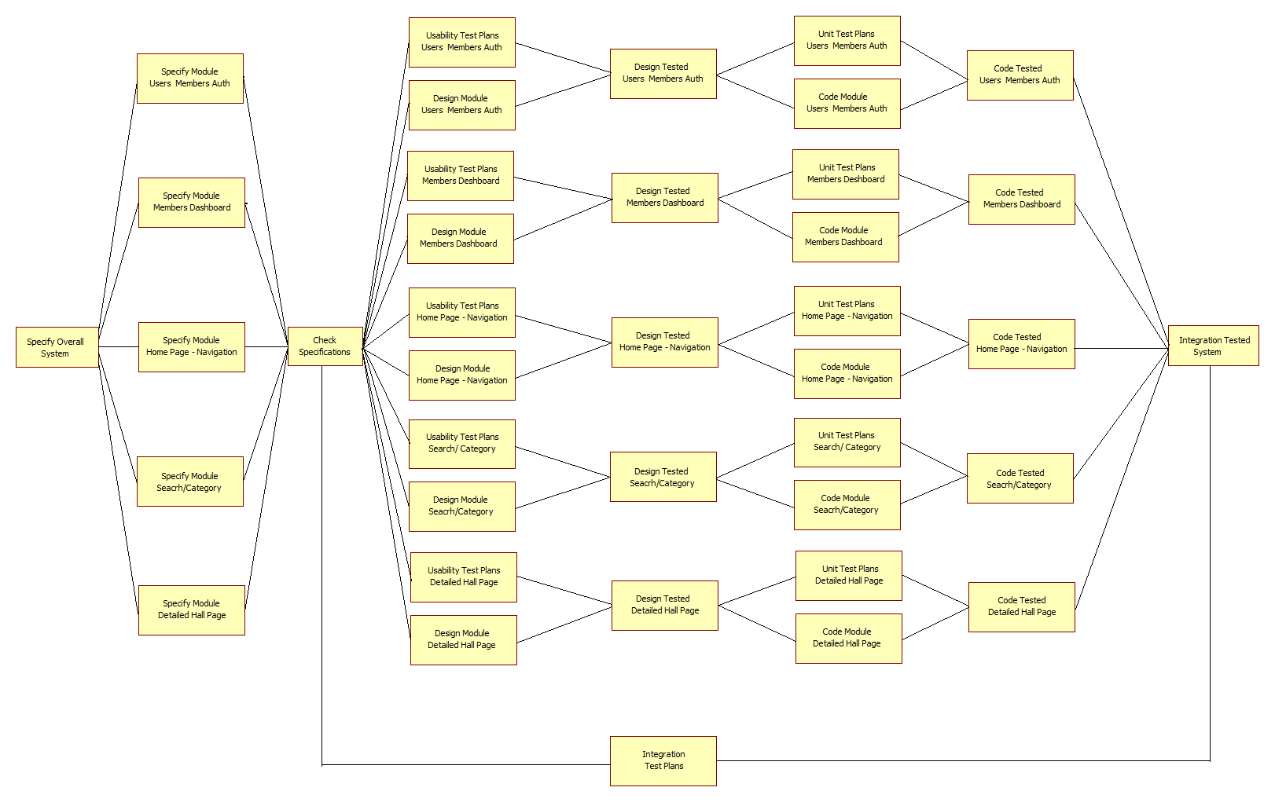

**Screenshots**

**Home Page Layout**

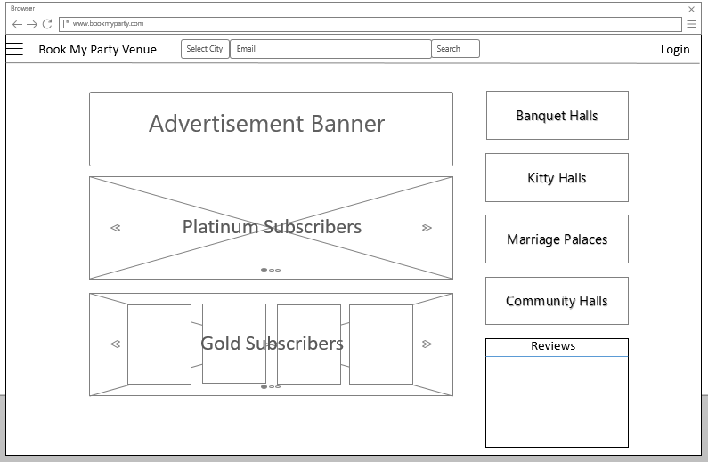

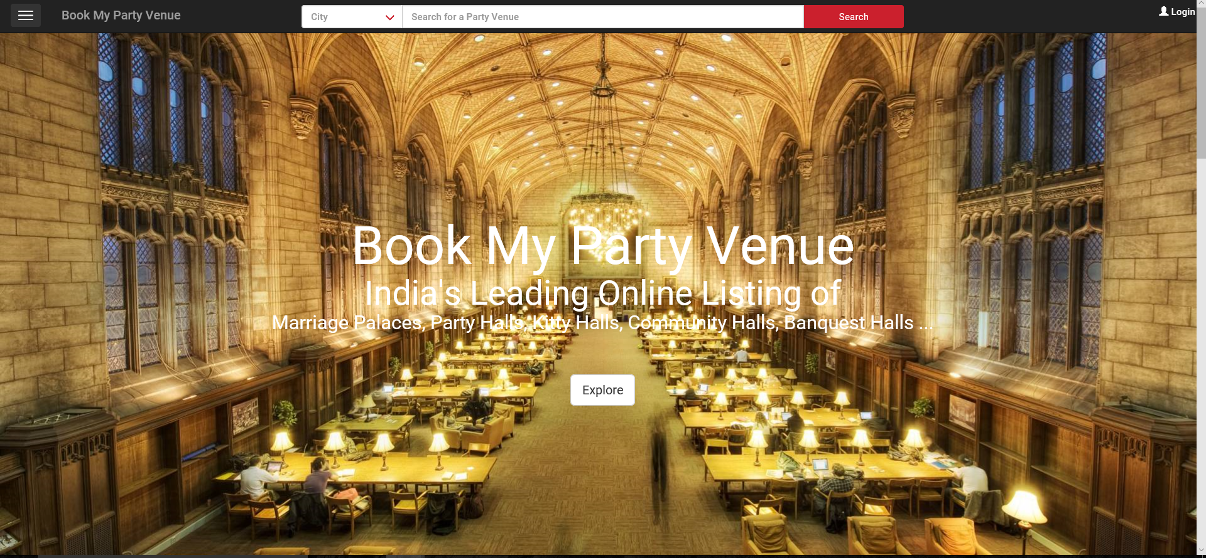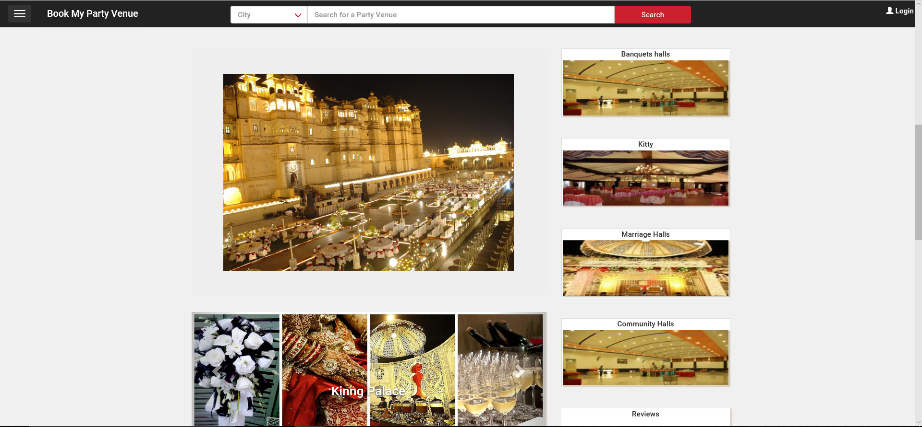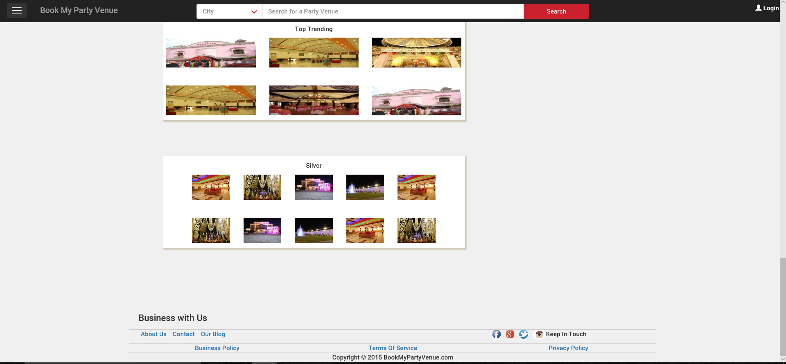

**Advertise/Business with us**

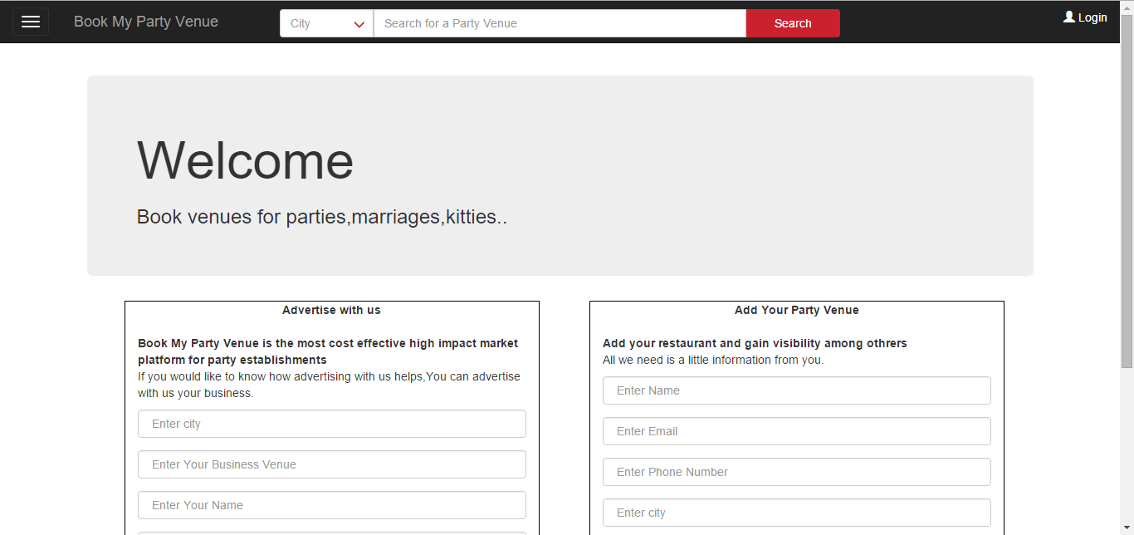

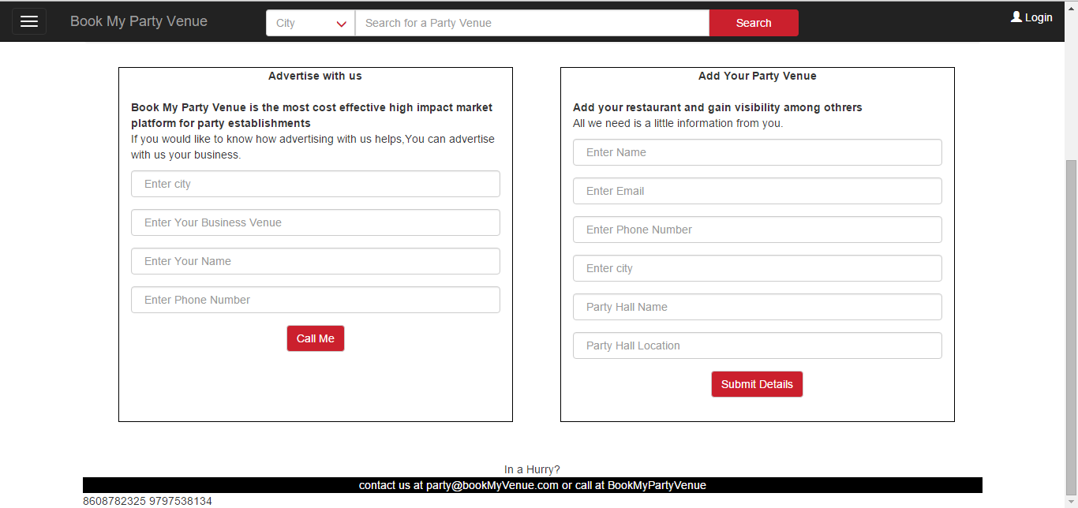

**Login/ Register**

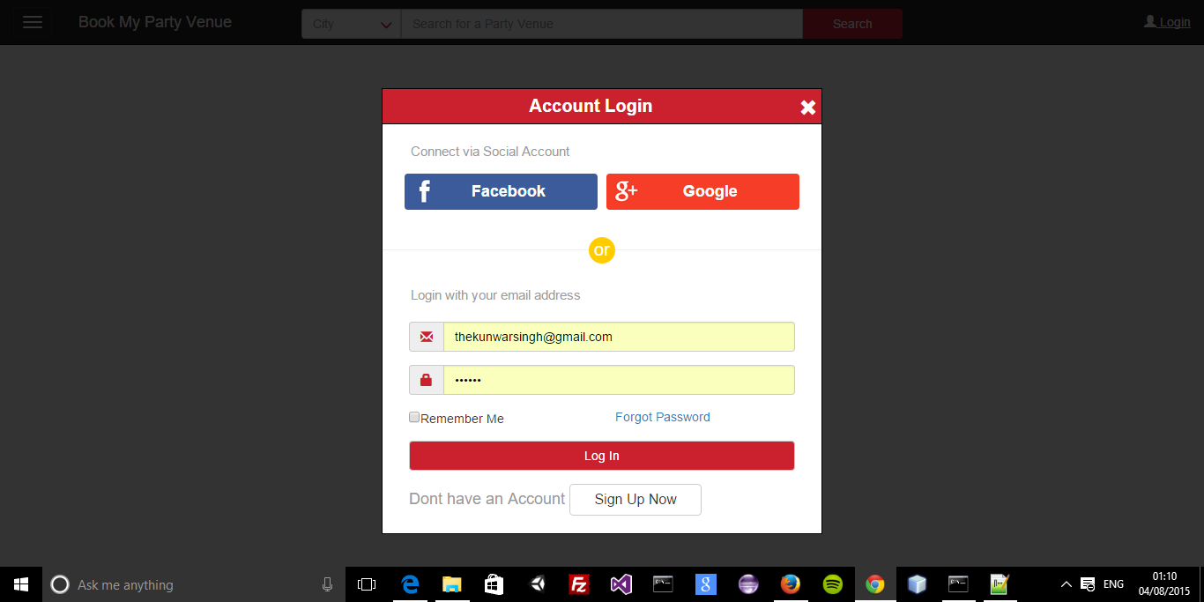

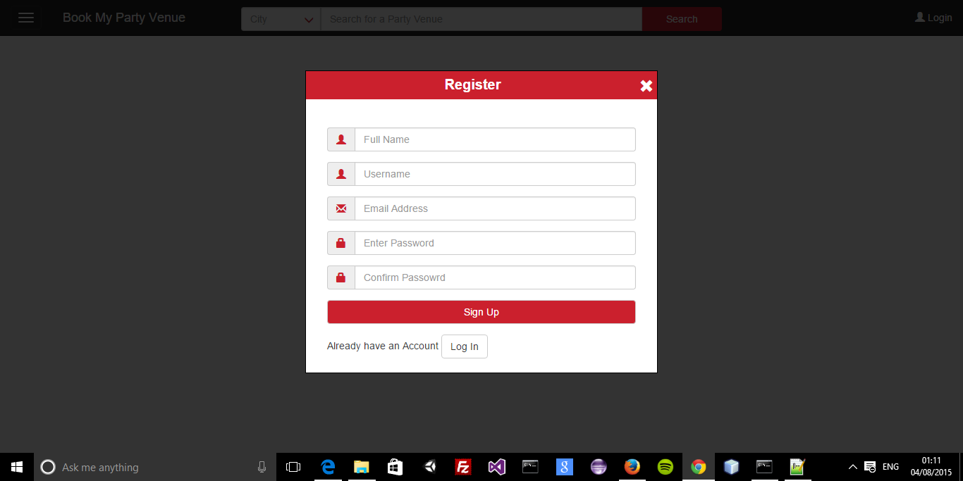

**Members verification**

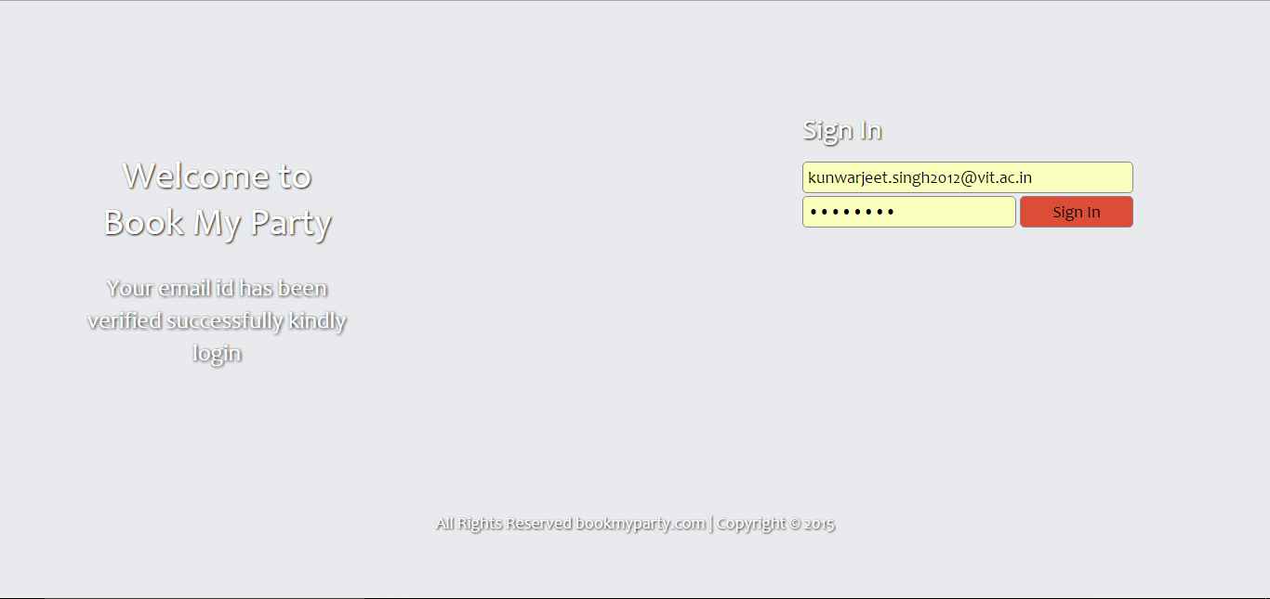

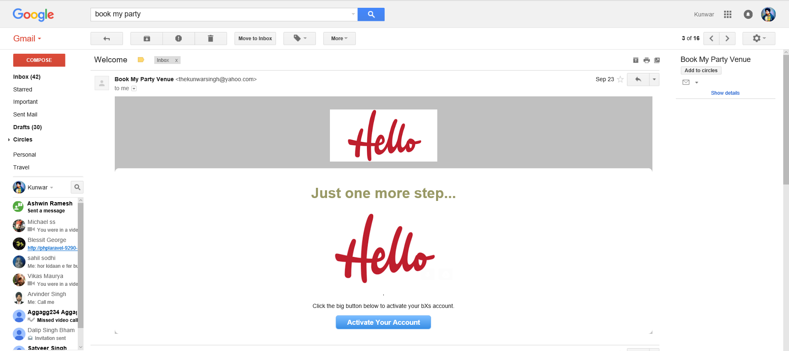

Database Schema

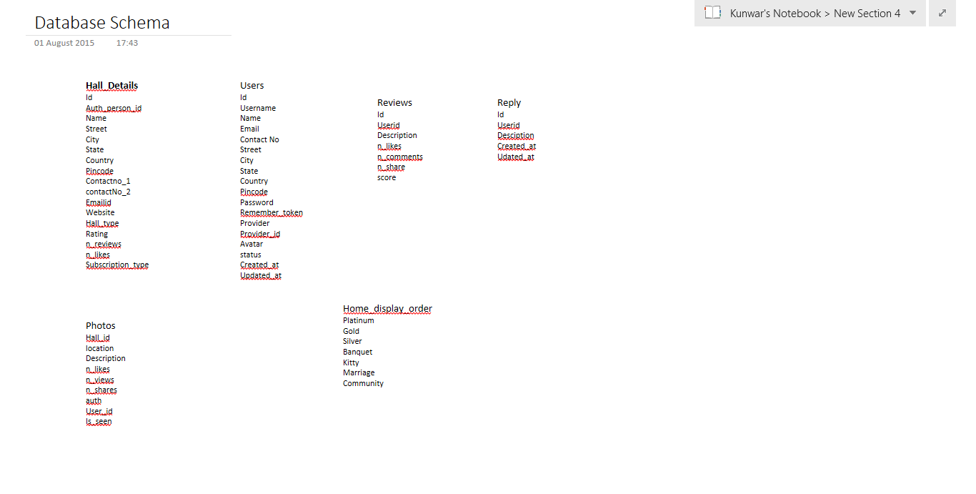

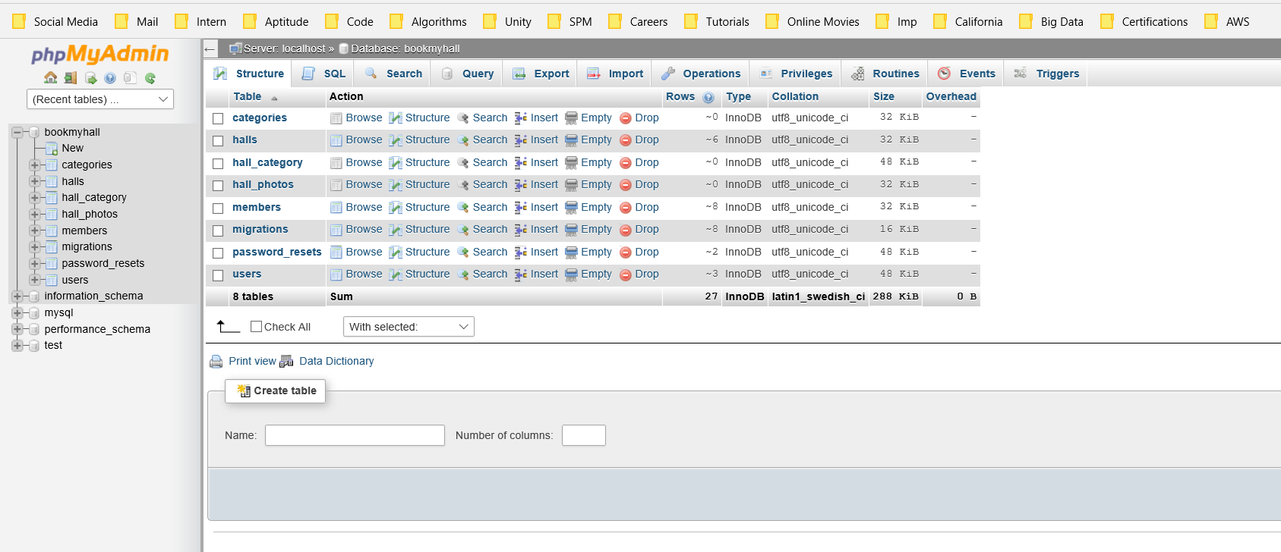

Members Dashboard

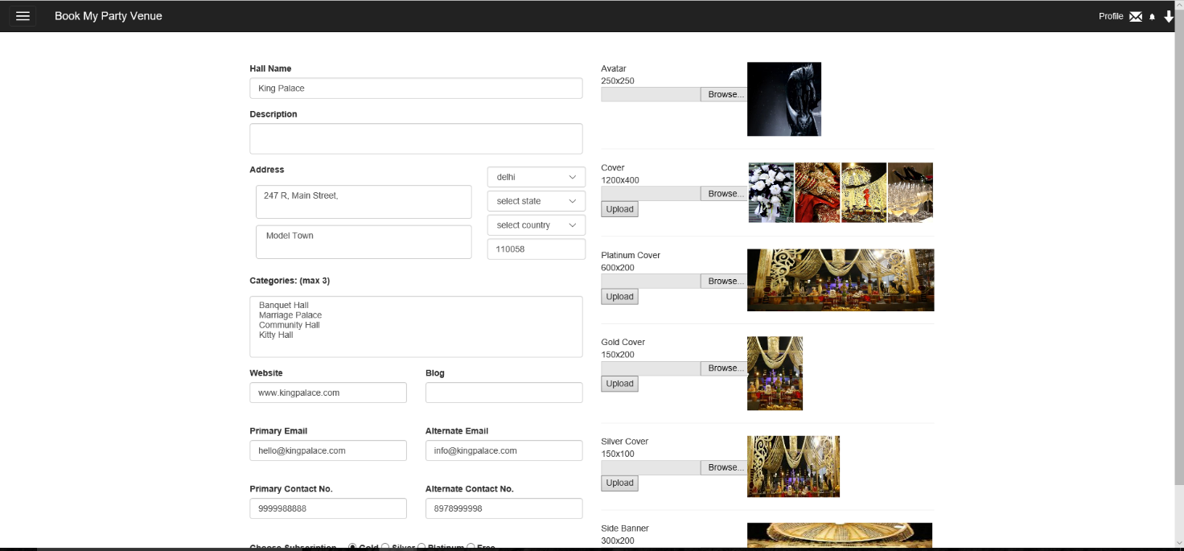

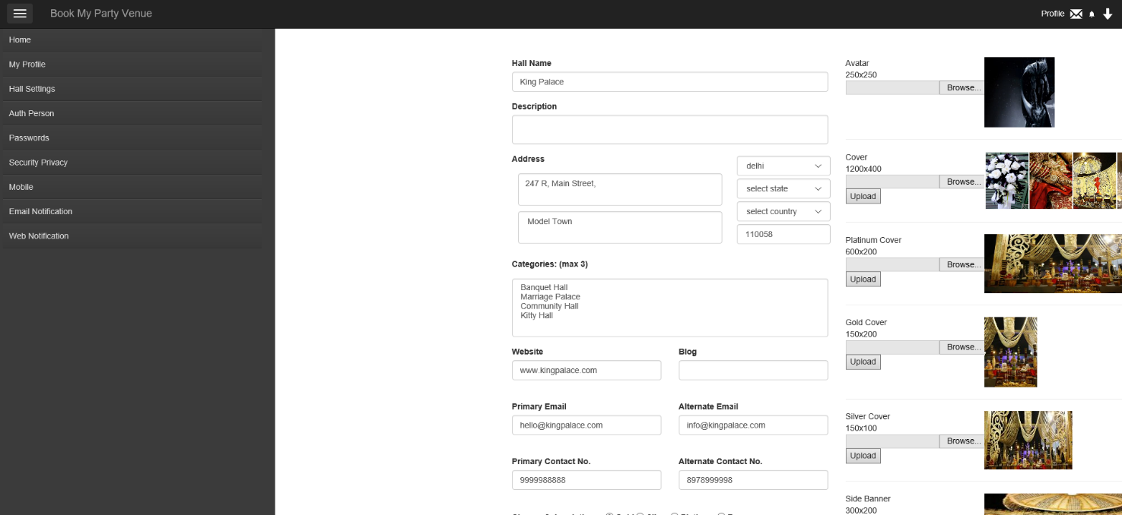

Sample Code

1. **addbusiness**

public function addBusiness(\Illuminate\Http\Request $request){

$member = new Member;

$member->first_name=$request->first_name;

$member->email=$request->email;

$member->contact=$request->contact;

$member->hash_key=str_random(60);

$member->password=str_random(8);

$member->save();

$hall = new Hall;

$hall->name=$request->hall_name;

$hall->city=$request->hall_city;

$hall->street=$request->hall_address;

$member->halls()->save($hall);

// Auth::user()->content()->save($content);

// $content->meme()->save($meme);

if(Mail::send('emails.welcome', ['member' => $member], function ($m) use ($member) {

$m->to($member->email, $member->first_name)->subject('Welcome');

}))

return "Mail Sent";

else

return "fail";

}

1. **Verify/ resend Email**

public function verify($id,\Illuminate\Http\Request $request){

$user_status="inactive";

$key=explode('-',$id);

$member=Member::find($key[0]);

if($member->hash_key==$key[1])

{ $member->status=1;

$member->save();

$user_status="active";}

return view('emails.verify', compact('user_status'));

}

public function resend(\Illuminate\Http\Request $request){

$member=Member::where('email',$request->email)->get();

$member[0]->hash_key=str_random(60);

$member[0]->save();

$user=$member[0];

Mail::send('emails.welcome', ['member' => $user], function ($m) use ($member) {

$m->to($member[0]->email, $member[0]->first_name)->subject('Welcome');

});

//return view('emails.verify', compact('user_status');

}

1. **Image Upload**

public function uploadImage(\Illuminate\Http\Request $request){

if (Request::ajax()){

$fileName = $_FILES["file"]["name"];

$kaboom = explode(".", $fileName);

$ext = end($kaboom);

$target_path = 'images/halls/hall_' .$request->id.'_'.$request->type.'.'.$ext;

if(move_uploaded_file($_FILES['file']['tmp_name'], $target_path)) {

// echo "The file ". basename( $_FILES['file']['name']).

" has been uploaded";

} else{

// echo "There was an error uploading the file, please try again!";

}

Hall::where('id',$request->id)->update([$request->type=>'hall_' .$request->id.'_'.$request->type.'.'.$ext]);

$resized_file = 'images/halls/hall_' .$request->id.'_'.$request->type.'.'.$ext;

if($request->type=='avatar'){

$w=250; $h=250;}

else if($request->type=='cover'){

$w=1200; $h=400;}

else if($request->type=='platinum_cover'){

$w=600; $h=200;}

else if($request->type=='gold_cover'){

$w=150; $h=200;}

else if($request->type=='silver_cover'){

$w=150; $h=100;}

else if($request->type=='banner'){

$w=300; $h=100;}

list($w_orig, $h_orig) = getimagesize($target_path);

$img = "";

$ext = strtolower($ext);

if ($ext == "gif"){

$img = imagecreatefromgif($target_path);

} else if($ext =="png"){

$img = imagecreatefrompng($target_path);

} else {

$img = imagecreatefromjpeg($target_path);

}

$tci = imagecreatetruecolor($w, $h);

imagecopyresampled($tci, $img, 0, 0, 0, 0, $w, $h, $w_orig, $h_orig);

imagejpeg($tci, $resized_file, 80);

echo url('/images/halls/hall_'.$request->id.'_'.$request->type.'.'.$ext);

}

}

1. **Navbar**

<nav class="navbar navbar-inverse navbar-fixed-top" role="navigation">

<div class="navbar-header col-lg-3 col-md-3 col-sm-9 col-xs-9">

<button type="button" class="navbar-toggle offmenu btnMenu" data-toggle="offcanvas" data-target=".sidebar-nav">

<span class="icon-bar"></span>

<span class="icon-bar"></span>

<span class="icon-bar"></span>

</button>

<a class="navbar-brand" href="#">Book My Party Venue</a>

</div>

<div class="col-lg-6 col-md-6 searchBar searchBarLgMd" style="padding:10px 0px 0px 0px;">

<div class="col-lg-2 col-md-2" style="padding:0;">

<div class="inner-addon right-addon">

<input type="text" class="form-control selectCity" id="selectCity" placeholder="City" name="selectCity">

<span class="glyphicon glyphicon-menu-down" style="color:#cb202d;"></span>

</div>

</div>

<div class=" col-lg-8 col-md-8" style="padding:0;">

<input type="text" class="form-control search" id="search" placeholder="Search for a Party Venue" name="search">

</div>

<div class="col-lg-2 col-md-2" style="padding:0;">

<button type="button" class="btn searchBtn">Search</button>

</div>

</div>

<div class="col-lg-3 col-md-3 col-sm-3 col-xs-3" style="padding-top:10px;">

<ul id="" style="list-style: none; color:#ffffff;">

@if (Auth::guest())

<li id="loginBtn" class="DesktopLogin" ><a href="#" style="color:#ffffff;"><span class="glyphicon glyphicon-user" style="color:#ffffff;"></span> Login</a></li>

<li id="mloginBtn" class="MobileLogin"><a href="#" style="color:#ffffff;"><span class="glyphicon glyphicon-user" style="color:#ffffff; font-size:20px;"></span></a></li>

@else

<li class="dropdown" style="float:right;">

<img href="#" class="dropdown-toggle" data-toggle="dropdown" src="{{ Auth::user()->avatar }}" style="height:30px; width:30px; border-radius:100%; "> </img>

<ul class="dropdown-menu" style="left:-100px;" >

<li><a href="{{ url('/myprofile') }}"></span>My Profile</a></li>

<li><a href="{{ url('/memeGenerator') }}"></span>Settings</a></li>

<li><a href="{{ url('/auth/logout') }}"></span>Logout</a></li>

</ul>

</li>

<li id="notifBtn" style="float:right; margin-right:10px; margin-top:5px;" > <img src="{{ asset('/images/notif.png') }}" width="13"></img></li>

@endif

</ul>

</div>

<div class="col-sm-offset-1 col-sm-10 col-xs-12 searchBar searchBarSmXs" style="padding:0px 0px 0px 0px;">

<div class="col-sm-3 col-xs-3" style="">

<div class="inner-addon right-addon">

<input type="text" class="form-control selectCity" id="selectCity" placeholder="Enter City" name="selectCity">

<span class="glyphicon glyphicon-menu-down" style="color:white;"></span>

</div>

</div>

<div class=" col-sm-9 col-xs-9" style="">

<div class="searchLeftBorder1"></div>

<div class="searchLeftBorder2"></div>

<div class="inner-addon left-addon">

<span class="glyphicon glyphicon-search" style="color:white;"></span>

<input type="text" class="form-control search" id="search" placeholder="Search for a Party Venue" name="search">

</div>

<div class="searchRightBorder1"></div>

<div class="searchRightBorder2"></div>

</div>

</div>

</nav>

1. **Members Dashboard**

{!! Form::model($hall,['method' => 'PATCH' , 'action' => ['MainController@updateHall',$hall->id] ]) !!}

<div class="col-lg-6" >

<div class="form-group" >

{!! Form::label('name','Hall Name') !!}

{!! Form::text('name',null,['class'=>'form-control']) !!}

</div>

<div class="form-group" >

{!! Form::label('description','Description') !!}

{!! Form::textarea('description',null,['class'=>'form-control','style'=>'width: 100%; height:50px; resize:none;']) !!}

</div>

<div class="row form-group" >

<div class="col-lg-8">

{!! Form::label('address','Address') !!}

{!! Form::textarea('street',null,['class'=>'form-control','style'=>'width: 100%; height:55px; resize:none; margin:10px;']) !!}

{!! Form::textarea('suburb',null,['class'=>'form-control','style'=>'width: 100%; height:55px; resize:none; margin:10px;']) !!}

</div>

<div class="col-lg-4">

{!! Form::select('city',['select city','chennai','delhi'],null,['class'=>'form-control','style'=>'margin:5px;']) !!}

{!! Form::select('state',['select state','chennai','delhi'],null,['class'=>'form-control','style'=>'margin:5px;']) !!}

{!! Form::select('country',['select country','chennai','delhi'],null,['class'=>'form-control','style'=>'margin:5px;']) !!}

{!! Form::text('pincode',null,['class'=>'form-control','style'=>'margin:5px;','placeholder'=>'Pincode']) !!}

</div>

</div>

<div class="form-group" >

{!! Form::label('category_list','Categories: (max 3)') !!} <p id="msg" style="color:red;"></p>

{!! Form::select('category_li[]',['Banquet Hall','Marriage Palace','Community Hall','Kitty Hall'],null,['class'=>'form-control','multiple','style'=>'height:100px;']) !!}

</div>

<div class="row form-group" >

<div class="col-lg-6">

{!! Form::label('website','Website') !!}

{!! Form::text('website',null,['class'=>'form-control']) !!}

</div>

<div class="col-lg-6">

{!! Form::label('blog','Blog') !!}

{!! Form::text('blog',null,['class'=>'form-control']) !!}

</div>

</div>

<br>

<div class="row form-group" >

<div class="col-lg-6">

{!! Form::label('primary_email','Primary Email') !!}

{!! Form::text('primary_email',null,['class'=>'form-control']) !!}

</div>

<div class="col-lg-6">

{!! Form::label('alternate_email','Alternate Email') !!}

{!! Form::text('alternate_email',null,['class'=>'form-control']) !!}

</div>

</div><br>

<div class="row form-group" >

<div class="col-lg-6">

{!! Form::label('primary_contact','Primary Contact No.') !!}

{!! Form::text('primary_contact',null,['class'=>'form-control']) !!}

</div>

<div class="col-lg-6">

{!! Form::label('alternate_contact','Alternate Contact No.') !!}

{!! Form::text('alternate_contact',null,['class'=>'form-control']) !!}

</div>

</div><br>

<div class="form-group" >

{!! Form::label('','Choose Subscription') !!} &nbsp &nbsp

{!! Form::radio('subscription','gold',null,['id'=>'s1']) !!}

{!! Form::label('subscription','Gold') !!}

{!! Form::radio('subscription','silver',null,['id'=>'s2']) !!}

{!! Form::label('subscription','Silver') !!}

{!! Form::radio('subscription','platinum',null,['id'=>'s3']) !!}

{!! Form::label('subscription','Platinum') !!}

{!! Form::radio('subscription','free',true,['id'=>'s4']) !!}

{!! Form::label('subscription','Free') !!}

</div>

<div class="form-group" >

{!! Form::submit('Update Changes',['class'=>'btn btn-primary']) !!}

</div>

</div>

1. **AJAX Call To Upload Image**

<script>

function upload(item){

console.log(item.name);

var file = $("#"+item.id).prop('files')[0];

var data = new FormData();

data.append('file', file);

data.append('id',{{$hall->id}});

data.append('type',item.name);

console.log(data);

jQuery.ajax({

url: '/members/settings/uploadimg',

data: data,

headers: { 'X-CSRF-Token' : $('meta[name=_token]').attr('content') },

cache: false,

contentType: false,

processData: false,

type: 'POST',

success: function(data){

console.log(data);

//$("#result1").append(data);

// console.log(document.getElementById(item.id));

//var str = document.getElementById(item.id).src.split("\");

document.getElementById(item.id+'img').src=data;

console.log("success");

}

});

}

</script>